# Descriptive vs. Inferential Statistics - Solution

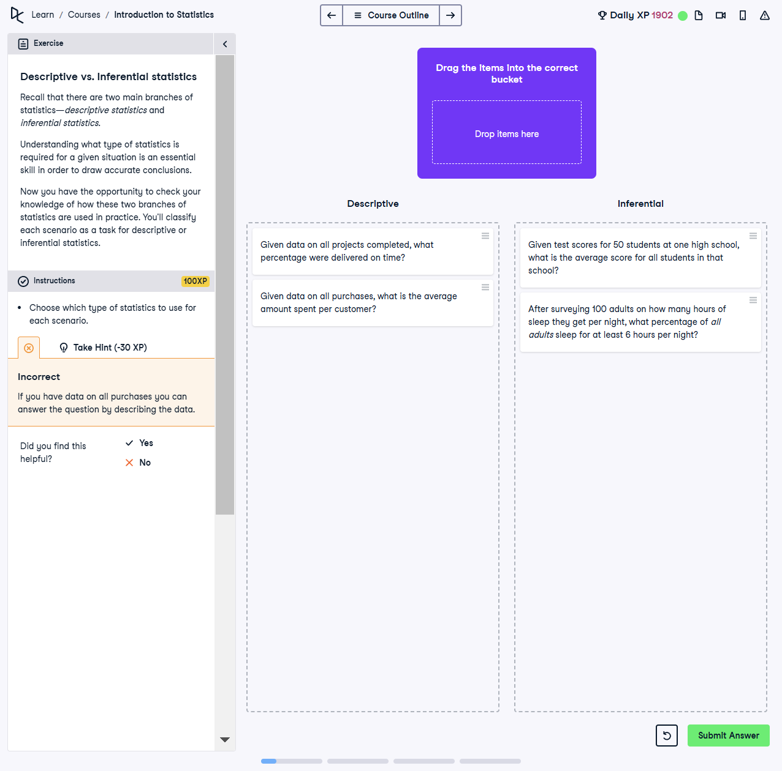

## Question

Recall that there are two main branches of statistics—descriptive statistics and inferential statistics.  
  
Understanding what type of statistics is required for a given situation is an essential skill in order to draw accurate conclusions.  
  
Now you have the opportunity to check your knowledge of how these two branches of statistics are used in practice. You’ll classify each scenario as a task for descriptive or inferential statistics.

## Instructions

Choose which type of statistics to use for each scenario.

## Solution

**Descriptive Statistics:**  
- Given data on all projects completed, what percentage were delivered on time?  
- Given data on all purchases, what is the average amount spent per customer?  
  
**Inferential Statistics:**  
- Given test scores for 50 students at one high school, what is the average score for all students in that school?  
- After surveying 100 adults on how many hours of sleep they get per night, what percentage of all adults sleep for at least 6 hours per night?

## Solution Explanation

1. **Descriptive Statistics:**  
 - These summarize or describe the characteristics of a dataset (e.g., average, percentage) using all available data.  
 - Examples:  
 - Percentage of on-time projects.  
 - Average spending per customer based on complete purchase data.  
  
2. **Inferential Statistics:**  
 - These use a sample to make predictions or inferences about a larger population.  
 - Examples:  
 - Inferring the average score for all students in a school from a sample.  
 - Predicting the percentage of all adults who sleep for at least 6 hours based on a sample survey.